Wizard of Oz
- Wizard of Oz method is a process that allows a user to interact with an interface without knowing that the responses are being generated by a human rather than a computer by having someone behind-the-scenes who is pulling the levers and flipping the switches.
- 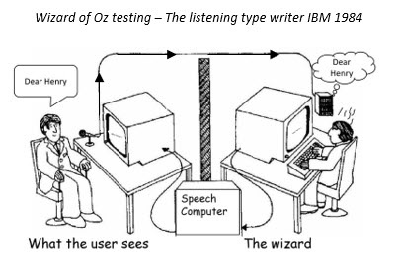
- Wizard of Oz method allows researchers to test a concept by having one practitioner – the ‘Moderator’ – leading the session face to face with each user, whilst another practitioner – the ‘Wizard’ – controls the responses sent to the user via the chosen device.
- Wizard of Oz methodology allows you to test users’ reactions to a system before you even have to think about development.
- Wizard of Oz is a flexible approach that allows concepts to be tested and modified without having to worry about potentially tiresome code changes, breaks in a daily testing schedule or full development costs.
- 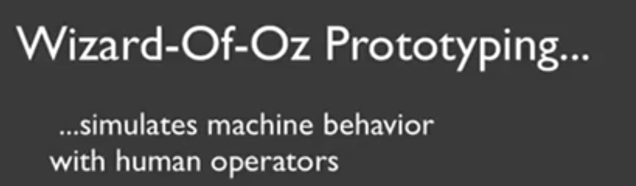
Wizard of Oz Technique
- Make an interactive application without (much) code
  - Front end interface
  - (Remote) wizard controls user interface
  - Makes sense when it's faster/cheaper/easier than making real thing
- Get feedback from users people
  - Hi-fidelity: users think it‘s more real
  - Low-fidelity: more license to suggest changes

Aardvark
"Why Start-Ups Must Pay Attention
To What's Behind The Curtain"
Venture Capital Dispatch - WSJ
Making a Wizard-Powered Prototype
- Map out scenarios and application flow
  - what should happen in response to user behavior?
- Put together interface "skeletons"
- Develop "hooks" for wizard input
- Where and how the wizard will provide input
  - selecting the next screen. entering text entering a zone. recognizing speech. Etc....
  - remember that later you'll need to replace with computer
- Rehearse wizard role with a colleague
Running Wizard-Powered Prototypes
- Practice with a friend first
- Once you're comfortable. recruit "users"
- Two roles: facilitator and wizard.
- Facilitator provides tasks (paper) and takes notes
- Wizard operates interface (more authentic if hidden or remote)
- User feedback can be…
  - Think aloud (speak freely as performing tasks)
  - Retrospective (best when think aloud distracts)
  - Heuristic evaluation (works with experts too)
- Debrief users (reveal wizard if needed)
Advantages of Wizards
- Fast (faster) and thus, cheaper and more iterative prototypes
- Creating multiple variations is easy
- More "real" than paper prototyping
- Identifies bugs and problems with current design
- Places the user at the center of development
- Can envision challenging-to-build application
- Designers learn by playing wizard
Disadvantages of Wizards
- Simulations may misrepresent otherwise imperfect tech
- May simulate technologies that do not exist (and may never)
- Wizards require training and (can be inconsistent
- Playing the wizard can be exhausting
- Some features (and limitations) are difficult/impossible to simulate effectively
- May be inappropriate in some venues (e.g.. home)

